**How Can You Know What Features Browsers Support?**

With new language specifications coming out every year and with browsers updating every other month, it can be quite challenging to know what browser supports which language features. Each browser maker (except for Safari) has a website that tracks its development status. Checkout the platform feature updates for each browser:

* Google Chrome - <https://www.chromestatus.com/features#ES6>
* Microsoft Edge - <https://developer.microsoft.com/en-us/microsoft-edge/platform/status/?q=ES6>
* Mozilla Firefox - <https://platform-status.mozilla.org/>

***NOTE:****Safari doesn't have it's own platform status website. Under the hood, though, Safari is powered by the open source browser engine, Webkit. The status for Webkit features can be found*[*here*](https://webkit.org/status/)*.*

This can be a lot of information to track down. If you prefer a birdseye view of all the feature support for all JavaScript code, check out the ECMAScript Compatibility Table built by [@kangax](https://twitter.com/kangax):

* <http://kangax.github.io/compat-table/es6/>

[[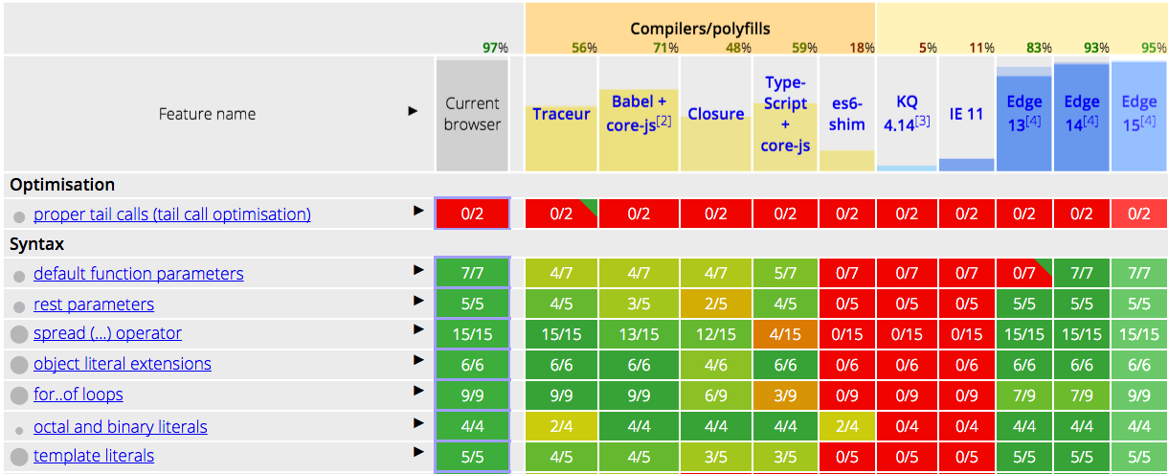](https://classroom.udacity.com/courses/ud356/lessons/2baa2512-b298-4796-aa5a-9135d82ff298/concepts/b3c593b2-e4f6-46d9-9551-e0e56af6a36f)](https://classroom.udacity.com/courses/ud356/lessons/2baa2512-b298-4796-aa5a-9135d82ff298/concepts/b3c593b2-e4f6-46d9-9551-e0e56af6a36f)

[Compatibility table of browser support for ECMAScript features.](https://classroom.udacity.com/courses/ud356/lessons/2baa2512-b298-4796-aa5a-9135d82ff298/concepts/b3c593b2-e4f6-46d9-9551-e0e56af6a36f)

**QUIZ QUESTION**

Looking at the ECMAScript Compatibility Table, what kind of information does the first *colored* column display?

* 

The list of up-to-date browsers that support ES6.

* 

The list of all ES6 features.

* The status of all ES6 features supported by your current browser.
* 

Links to each browser platform's status for the specific ES6 feature.

SUBMIT